**Part 1: Bug Finding Challenge - UI.**

***1. Title:* Bug**

***Test Environment:* https://wmxrwq14uc.execute-api.us-east-1.amazonaws.com/Prod/Account/Login**

***Severity:* Low**

***Description*: On the login page the Employer is able to click on the ”**[**Paylocity Benefits Dashboard**](https://wmxrwq14uc.execute-api.us-east-1.amazonaws.com/Prod/Benefits)**” sign. Then the user landed on the “**[**Paylocity Benefits Dashboard**](https://wmxrwq14uc.execute-api.us-east-1.amazonaws.com/Prod/Benefits)**” Add Employee Page. The Add Employee button is clickable. Employer is able to type First Name, Last Name, Dependents. Add button is not clickable. Cancel button is clickable.**

***Steps to reproduce:***

1. **Open https://wmxrwq14uc.execute-api.us-east-1.amazonaws.com/Prod/Account/Login**
2. **Click on the ”**[**Paylocity Benefits Dashboard**](https://wmxrwq14uc.execute-api.us-east-1.amazonaws.com/Prod/Benefits)**” sign => Add Employee button.**
3. **Type First Name, Last Name, Dependents => click Add button (not clickable).**
4. **Click on the cancel button.**

***Expected result:* Employer should not be able to land on the “**[**Paylocity Benefits Dashboard**](https://wmxrwq14uc.execute-api.us-east-1.amazonaws.com/Prod/Benefits)**” Add Employee Page after they click on the ”**[**Paylocity Benefits Dashboard**](https://wmxrwq14uc.execute-api.us-east-1.amazonaws.com/Prod/Benefits)**” sign.*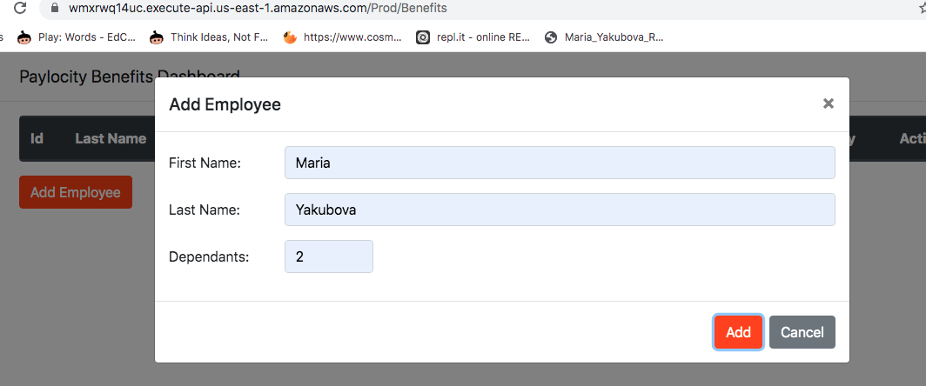***

***Actual results:***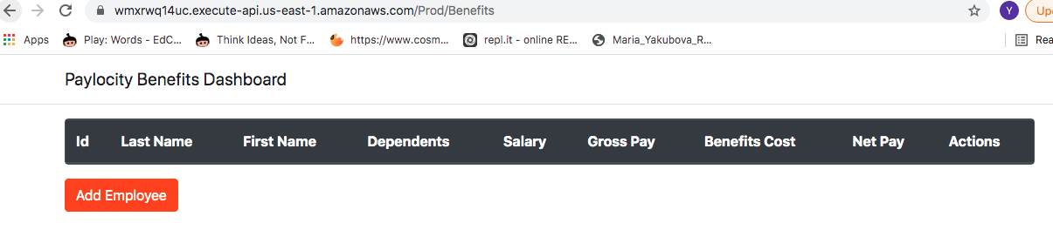

***2. Title:* Bug**

***Test data:*** [**https://wmxrwq14uc.execute-api.us-east-1.amazonaws.com/Prod/Account/LogIn**](https://wmxrwq14uc.execute-api.us-east-1.amazonaws.com/Prod/Account/LogIn)

***Username:* TestUser49**

***Password:* G#_0$A_mjp4-**

***Test Environment:* https://wmxrwq14uc.execute-api.us-east-1.amazonaws.com/Prod/Benefits**

***Severity:* High**

***Description*: Employer signed in on the “**[**Paylocity Benefits Dashboard**](https://wmxrwq14uc.execute-api.us-east-1.amazonaws.com/Prod/Benefits)**” Add Employee Page. Employer is able to click on the Add Employee button. Employer is able to type First Name, Last Name, Dependents. Employer is able to click on the Add Employee button.**

***Steps to reproduce:***

1. **Open** [**https://wmxrwq14uc.execute-api.us-east-1.amazonaws.com/Prod/Account/LogIn**](https://wmxrwq14uc.execute-api.us-east-1.amazonaws.com/Prod/Account/LogIn)
2. **Sign in: login - TestUser49; password - G#_0$A_mjp4-**
3. **Click on the Add Employee button.**
4. **Type First Name, Last Name, Dependents => click Add Employee button.**

***Expected result:* Employer should see under the Last Name - Last Name, under the First Name - First Name.**

***Actual results:* Under the Last Name Employer sees the First Name, under the First Name user sees the Last Name.**

**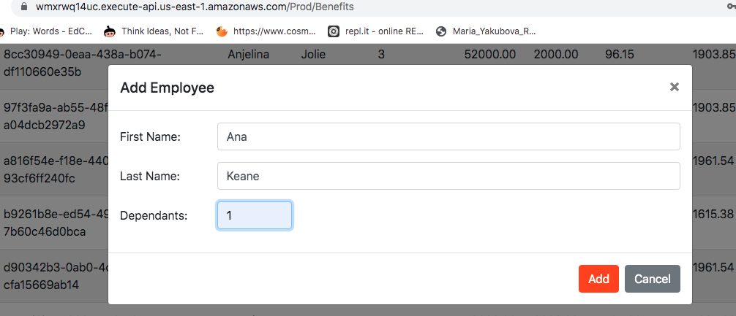*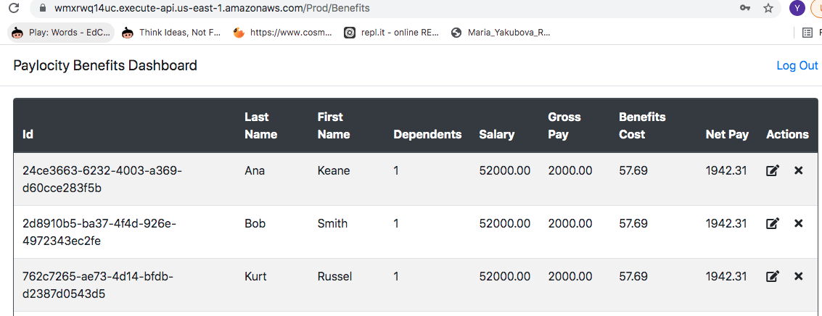***

***3. Title:* Bug**

***Test data:*** [**https://wmxrwq14uc.execute-api.us-east-1.amazonaws.com/Prod/Account/LogIn**](https://wmxrwq14uc.execute-api.us-east-1.amazonaws.com/Prod/Account/LogIn)

***Username:* TestUser49**

***Password:* G#_0$A_mjp4-**

***Test Environment:* https://wmxrwq14uc.execute-api.us-east-1.amazonaws.com/Prod/Benefits**

***Severity:* Low**

***Description*: Employer should be able to see the Employee List in alphabetical order by the Last Name.**

***Steps to reproduce:***

**1.Open** [**https://wmxrwq14uc.execute-api.us-east-1.amazonaws.com/Prod/Account/LogIn**](https://wmxrwq14uc.execute-api.us-east-1.amazonaws.com/Prod/Account/LogIn)

**2. Sign in: login - TestUser49; password - G#_0$A_mjp4-**

**3. Click on the Add Employee button.**

**4. Type First Name, Last Name, Dependents => click Add Employee button.**

***Expected result:* Employer should see the Employee List in alphabetical order by the Last Name.**

***Actual result:* Employer sees the Employee List is not in alphabetical order by the Last Name.**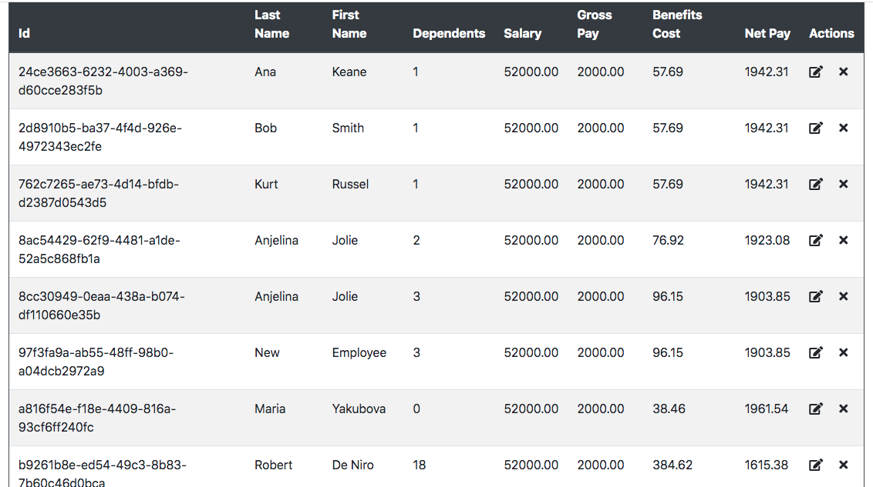

***4. Title:* Bug**

***Test data:*** [**https://wmxrwq14uc.execute-api.us-east-1.amazonaws.com/Prod/Account/LogIn**](https://wmxrwq14uc.execute-api.us-east-1.amazonaws.com/Prod/Account/LogIn)

***Username:* TestUser49**

***Password:* G#_0$A_mjp4-**

***Test Environment:* https://wmxrwq14uc.execute-api.us-east-1.amazonaws.com/Prod/Benefits**

***Severity:* Highest**

***Description*: When Employer adds between 5 and 17 dependents the benefit cost calculation is not correct.**

***Steps to reproduce:***

**1.Open** [**https://wmxrwq14uc.execute-api.us-east-1.amazonaws.com/Prod/Account/LogIn**](https://wmxrwq14uc.execute-api.us-east-1.amazonaws.com/Prod/Account/LogIn)

**2. Sign in: login - TestUser49; password - G#_0$A_mjp4-**

**3. Click on the Add Employee button.**

**4. Type First Name, Last Name, Dependents = 5 => click Add Employee button.**

***Expected result:* Employer should see the Benefits Cost = 134.61.**

***Actual result:* User sees the Benefits Cost = 134.62.**

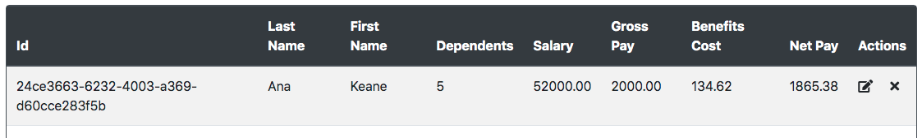

***5. Title:* Bug**

***Test data:*** [**https://wmxrwq14uc.execute-api.us-east-1.amazonaws.com/Prod/Account/LogIn**](https://wmxrwq14uc.execute-api.us-east-1.amazonaws.com/Prod/Account/LogIn)

***Username:* TestUser49**

***Password:* G#_0$A_mjp4-**

***Test Environment:* https://wmxrwq14uc.execute-api.us-east-1.amazonaws.com/Prod/Benefits**

***Severity:* Highest**

***Description*: When Employer adds between 18 and 30 dependents the benefit cost calculation is not correct.**

***Steps to reproduce:***

**1.Open** [**https://wmxrwq14uc.execute-api.us-east-1.amazonaws.com/Prod/Account/LogIn**](https://wmxrwq14uc.execute-api.us-east-1.amazonaws.com/Prod/Account/LogIn)

**2. Sign in: login - TestUser49; password - G#_0$A_mjp4-**

**3. Click on the Add Employee button.**

**4. Type First Name, Last Name, Dependents = 18 => click Add Employee button.**

***Expected result:* User should see the Benefits Cost = 384.60.**

***Actual result:* User sees the Benefits Cost = 384.62.**

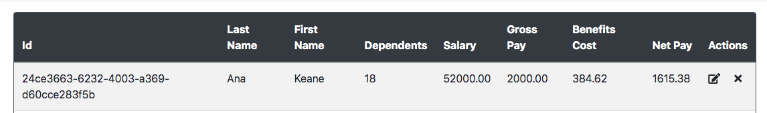

***6. Title:* Bug**

***Test data:*** [**https://wmxrwq14uc.execute-api.us-east-1.amazonaws.com/Prod/Account/LogIn**](https://wmxrwq14uc.execute-api.us-east-1.amazonaws.com/Prod/Account/LogIn)

***Username:* TestUser49**

***Password:* G#_0$A_mjp4-**

***Test Environment:* https://wmxrwq14uc.execute-api.us-east-1.amazonaws.com/Prod/Benefits**

***Severity:* Highest**

***Description*: When Employer adds 31 or 32 dependents the benefit cost calculation is not correct.**

***Steps to reproduce:***

**1.Open** [**https://wmxrwq14uc.execute-api.us-east-1.amazonaws.com/Prod/Account/LogIn**](https://wmxrwq14uc.execute-api.us-east-1.amazonaws.com/Prod/Account/LogIn)

**2. Sign in: login - TestUser49; password - G#_0$A_mjp4-**

**3. Click on the Add Employee button.**

**4. Type First Name, Last Name, Dependents = 31 => click Add Employee button.**

***Expected result:* User should see the Benefits Cost = 634.59.**

***Actual result:* Employer sees the Benefits Cost = 634.62.**

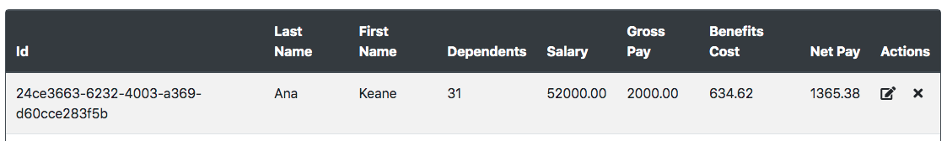

***7. Title:* Bug**

***Test data:*** [**https://wmxrwq14uc.execute-api.us-east-1.amazonaws.com/Prod/Account/LogIn**](https://wmxrwq14uc.execute-api.us-east-1.amazonaws.com/Prod/Account/LogIn)

***Username:* TestUser49**

***Password:* G#_0$A_mjp4-**

***Test Environment:* https://wmxrwq14uc.execute-api.us-east-1.amazonaws.com/Prod/Benefits**

***Severity:* High**

***Description*: Employer is able to add only 32 dependents.**

***Steps to reproduce:***

**1.Open** [**https://wmxrwq14uc.execute-api.us-east-1.amazonaws.com/Prod/Account/LogIn**](https://wmxrwq14uc.execute-api.us-east-1.amazonaws.com/Prod/Account/LogIn)

**2. Sign in: login - TestUser49; password - G#_0$A_mjp4-**

**3. Click on the Add Employee button.**

**4. Type First Name, Last Name, Dependents = 33 => click Add Employee button.**

***Expected result:* User should be able to add an unlimited number of dependents.**

***Actual result:* Add button is not clickable.**

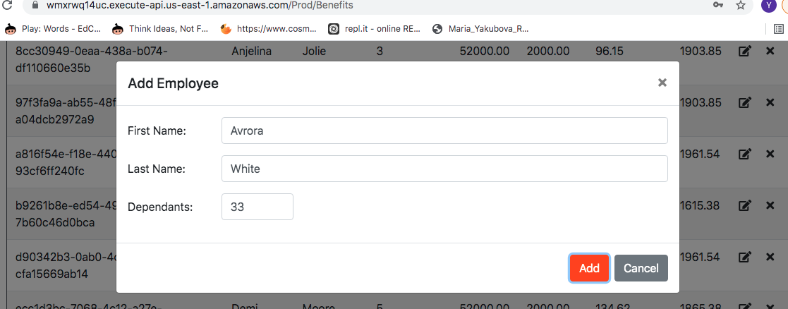

***8. Title:* Bug**

***Test data:*** [**https://wmxrwq14uc.execute-api.us-east-1.amazonaws.com/Prod/Account/LogIn**](https://wmxrwq14uc.execute-api.us-east-1.amazonaws.com/Prod/Account/LogIn)

***Username:* TestUser49**

***Password:* G#_0$A_mjp4-**

***Test Environment:* https://wmxrwq14uc.execute-api.us-east-1.amazonaws.com/Prod/Benefits**

***Severity:* High**

***Description*:Employer is able to update Last Name and First Name up to 50 numbers.**

***Steps to reproduce:***

**1.Open** [**https://wmxrwq14uc.execute-api.us-east-1.amazonaws.com/Prod/Account/LogIn**](https://wmxrwq14uc.execute-api.us-east-1.amazonaws.com/Prod/Account/LogIn)

**2. Sign in: login - TestUser49; password - G#_0$A_mjp4-**

**3. Click on the ActionsModule => edit button.**

**4. Type First Name and Last Name 50 numbers => click Update button.**

***Expected result:* Employer should not be able to update Last Name and First Name to numbers.**

***Actual result:* First Name and Last Name updated to 50 numbers.**

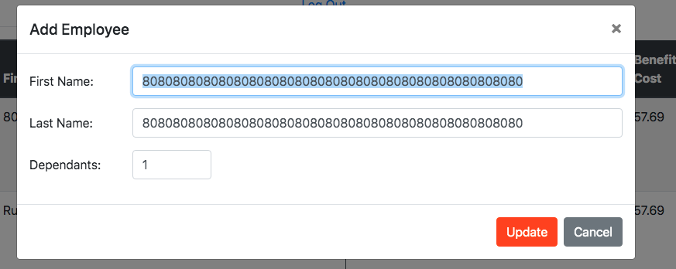

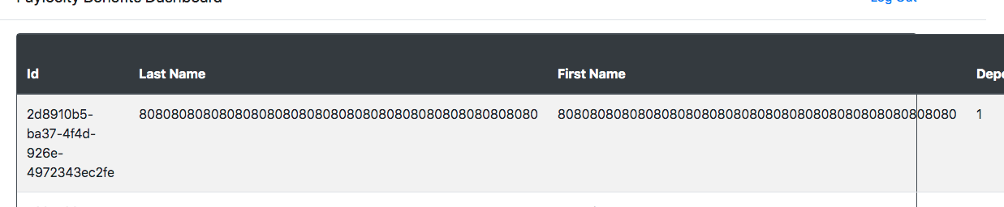

***9. Title:* Bug**

***Test data:*** [**https://wmxrwq14uc.execute-api.us-east-1.amazonaws.com/Prod/Account/LogIn**](https://wmxrwq14uc.execute-api.us-east-1.amazonaws.com/Prod/Account/LogIn)

***Username:* TestUser49**

***Password:* G#_0$A_mjp4-**

***Test Environment:* https://wmxrwq14uc.execute-api.us-east-1.amazonaws.com/Prod/Benefits**

***Severity:* High**

***Description*: Employer is able to update Last Name and First Name with letters and numbers.**

***Steps to reproduce:***

**1.Open** [**https://wmxrwq14uc.execute-api.us-east-1.amazonaws.com/Prod/Account/LogIn**](https://wmxrwq14uc.execute-api.us-east-1.amazonaws.com/Prod/Account/LogIn)

**2. Sign in: login - TestUser49; password - G#_0$A_mjp4-**

**3. Click on the ActionsModule => edit button.**

**4. Type First Name ,Last Name and add numbers => click Update button.**

***Expected result:* User should not be able to update Last Name and First Name to letters and numbers.**

***Actual result:* First Name and Last Name updated with letters and numbers.**

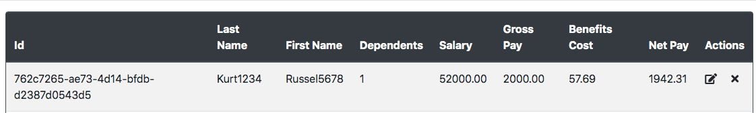

***10. Title:* Bug**

***Test data:*** [**https://wmxrwq14uc.execute-api.us-east-1.amazonaws.com/Prod/Account/LogIn**](https://wmxrwq14uc.execute-api.us-east-1.amazonaws.com/Prod/Account/LogIn)

***Username:* TestUser49**

***Password:* G#_0$A_mjp4-**

***Test Environment:* https://wmxrwq14uc.execute-api.us-east-1.amazonaws.com/Prod/Benefits**

***Severity:* High**

***Description*: After a certain amount of time without the actions on the “**[**Paylocity Benefits Dashboard**](https://wmxrwq14uc.execute-api.us-east-1.amazonaws.com/Prod/Benefits)**” page, Update and Add Employees buttons are frozen. Then the Employer clicks the refresh button and lands on the wrong “**[**Paylocity Benefits Dashboard**](https://wmxrwq14uc.execute-api.us-east-1.amazonaws.com/Prod/Benefits)**” page .**

***Steps to reproduce:***

**1.Open** [**https://wmxrwq14uc.execute-api.us-east-1.amazonaws.com/Prod/Account/LogIn**](https://wmxrwq14uc.execute-api.us-east-1.amazonaws.com/Prod/Account/LogIn)

**2. Sign in: login - TestUser49; password - G#_0$A_mjp4-**

**3. After a certain amount of time click on the refresh button.**

***Expected result:* User should land on the login page.**

***Actual result:* Employer is on the wrong “**[**Paylocity Benefits Dashboard**](https://wmxrwq14uc.execute-api.us-east-1.amazonaws.com/Prod/Benefits)**” page .**

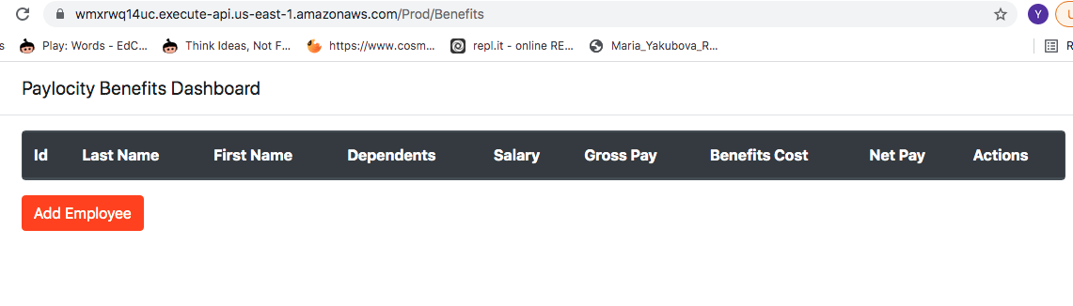

***11. Title:* Bug**

***Test data:*** [**https://wmxrwq14uc.execute-api.us-east-1.amazonaws.com/Prod/Account/LogIn**](https://wmxrwq14uc.execute-api.us-east-1.amazonaws.com/Prod/Account/LogIn)

***Username:* TestUser49**

***Password:* G#_0$A_mjp4-**

***Test Environment:* https://wmxrwq14uc.execute-api.us-east-1.amazonaws.com/Prod/Benefits**

***Severity:* Medium**

***Description*:On the employee table the cell “Number of employee” does not exist.**

***Steps to reproduce:***

**1.Open** [**https://wmxrwq14uc.execute-api.us-east-1.amazonaws.com/Prod/Account/LogIn**](https://wmxrwq14uc.execute-api.us-east-1.amazonaws.com/Prod/Account/LogIn)

**2. Sign in: login - TestUser49; password - G#_0$A_mjp4-**

**3. Employer is on the “**[**Paylocity Benefits Dashboard**](https://wmxrwq14uc.execute-api.us-east-1.amazonaws.com/Prod/Benefits)**” page.**

***Expected result:* The cell “Number of employee” on the table should be present.**

***Actual result:* The cell “Number of employee” on the table does not exist.**



***12. Title:* Bug**

***Test data:*** [**https://wmxrwq14uc.execute-api.us-east-1.amazonaws.com/Prod/Account/LogIn**](https://wmxrwq14uc.execute-api.us-east-1.amazonaws.com/Prod/Account/LogIn)

***Username:* TestUser49**

***Password:* G#_0$A_mjp4-**

***Test Environment:* https://wmxrwq14uc.execute-api.us-east-1.amazonaws.com/Prod/Benefits**

***Severity:* Low**

***Description*: Header name doesn't match the action type.**

***Steps to reproduce:***

**1.Open** [**https://wmxrwq14uc.execute-api.us-east-1.amazonaws.com/Prod/Account/LogIn**](https://wmxrwq14uc.execute-api.us-east-1.amazonaws.com/Prod/Account/LogIn)

**2. Sign in: login - TestUser49; password - G#_0$A_mjp4-**

**3. Click on the ActionsModule => edit button.**

**4.Edit window appears.**

***Expected result:* Header name should be Edit Employee.**

***Actual result:* Header name is Add Employee.**

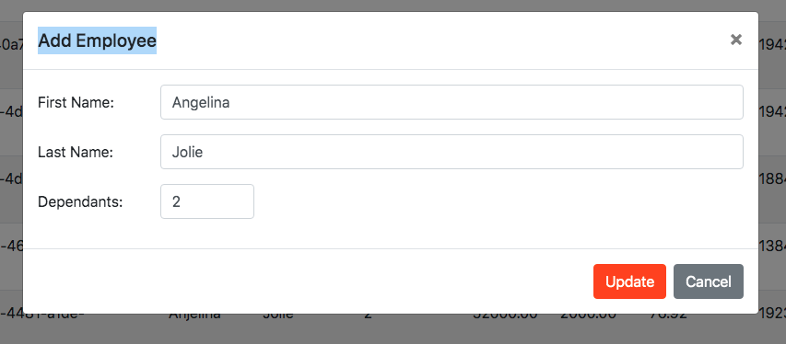

***13. Title:* Defect**

***Test data:*** [**https://wmxrwq14uc.execute-api.us-east-1.amazonaws.com/Prod/Account/LogIn**](https://wmxrwq14uc.execute-api.us-east-1.amazonaws.com/Prod/Account/LogIn)

***Username:* TestUser49**

***Password:* G#_0$A_mjp4-**

***Test Environment:* https://wmxrwq14uc.execute-api.us-east-1.amazonaws.com/Prod/Benefits**

***Severity:* Low**

***Description*: In the Edit and Add Employee windows there is a typo in the word Dependent.**

***Steps to reproduce:***

**1.Open** [**https://wmxrwq14uc.execute-api.us-east-1.amazonaws.com/Prod/Account/LogIn**](https://wmxrwq14uc.execute-api.us-east-1.amazonaws.com/Prod/Account/LogIn)

**2. Sign in: login - TestUser49; password - G#_0$A_mjp4-**

**3. Click on the ActionsModule => Edit button or click on the Add Employee button.**

**4.Edit or Add Employee window appears.**

***Expected result:* Word Dependants should be written in the correct grammar like Dependents.**

***Actual result:* Employer *sees word Dependants*.**

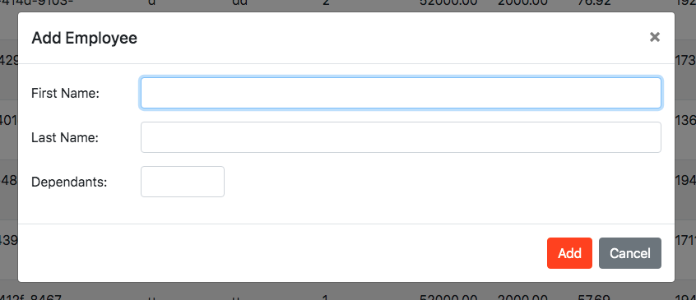



***Expected result:* Word Dependants should be written in the correct grammar like Dependents.**